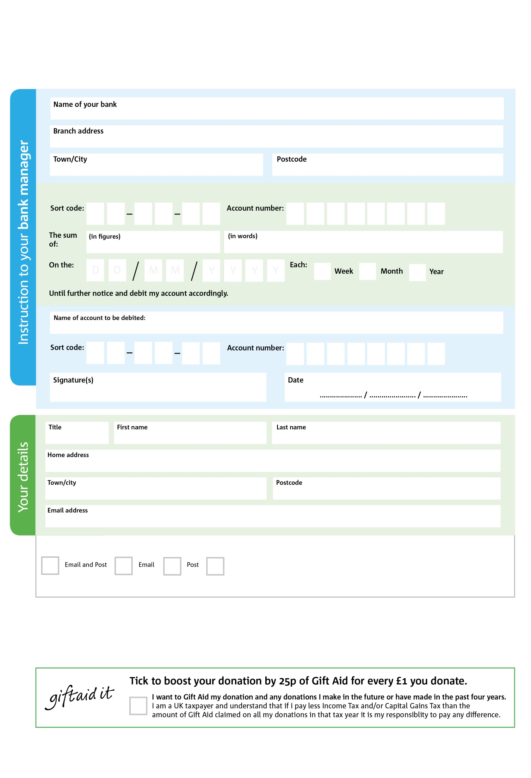

**Data protection**

*'Kinson & West Howe Foodbank is committed to protecting your privacy and will process your personal data in accordance with current Data Protection legislation. Kinson & West Howe Foodbank collects information to keep in touch with you and supply you with information relating to our work. To unsubscribe from our newsletter, send a message to the email address above with the word unsubscribe in the subject line. A full data privacy statement for financial donors is available from the foodbank on request.’*

Reg. Charity No: 1138074 | Reg. in England & Wales

**Standing Order Mandate**

**www.kinsonwesthowe.foodbank.org.uk**

Please pay Kinson and West Howe Foodbank,

POSTAL ADDRESS: Kinson & West Howe Foodbank, St.Andrew’s Church, Millhams Road, Bournemouth, BH10 7LN

5

V

4

V

1

V

0

V

3

V

0

V

0

V

0

V

**Please pass this form onto the foodbank, using the foodbank’s address at the bottom, who will save a copy for their records.   
They will then send it onto your named bank or building society.**

0

4

2

5

0

4

We would love to keep you up to date with information about Kinson & West Howe Foodbank. Please tick your preference:

You can change your preferences any time by contacting us on 01202 647911 or emailing us at info@kinsonwesthowe.foodbank.org.uk

I do not wish to receive future communications from Kinson & West Howe Foodbank

You can change your preferences any time by contacting us on XXXXXXXXXXX or emailing us at XXXX@XXXXXXXXXX.foodbank.org.uk

I do not wish to receive future communications from XXXXXX Foodbank